**HANDSON 17 : Create a Spring Web Project using Maven**

Output Snapshot:

**Build the Project:**

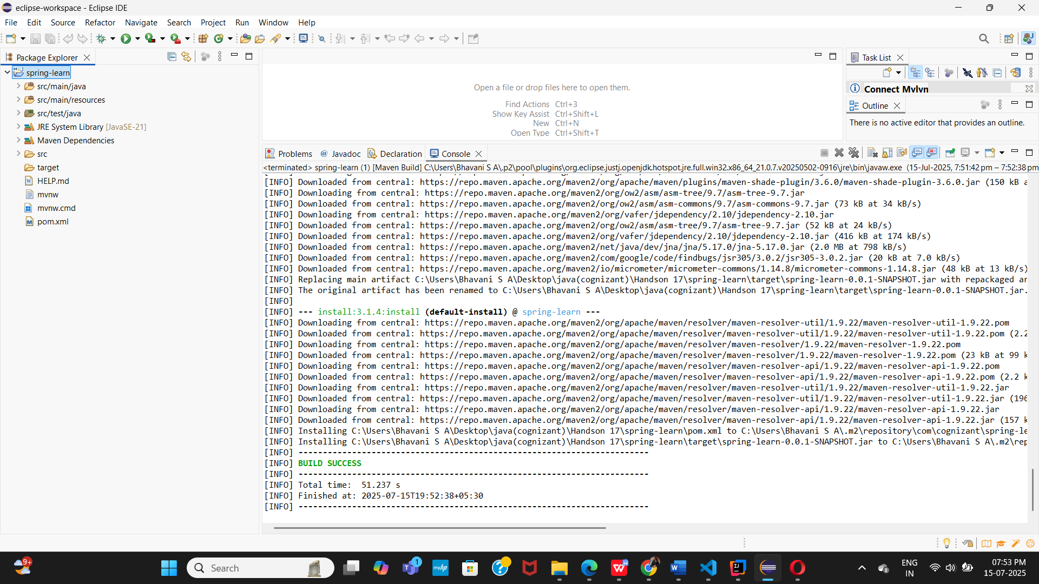

**Run Java Application:**

